Practical Task 4 – Data Exploration and Cleaning using Pandas

Objective
To load, explore, and clean data using Pandas library in Python.

Tools Used
Anaconda
Jupyter Notebook
Python (Pandas)

Dataset
Titanic Dataset

Tasks Performed
1. Data Loading (CSV, Excel, JSON)
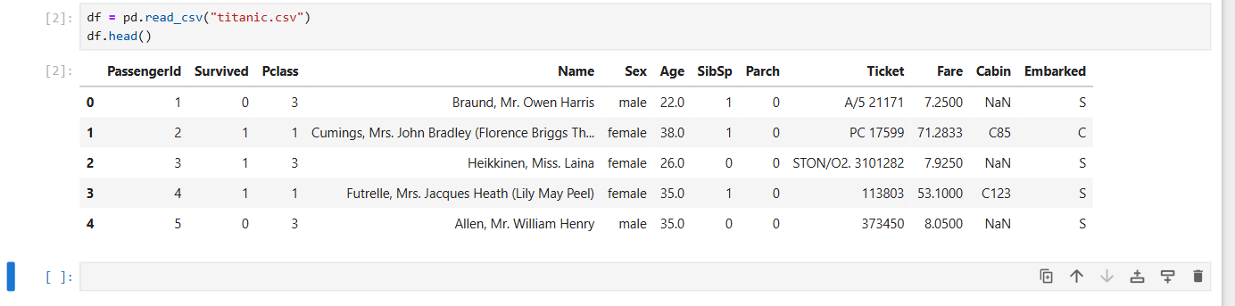
2. Data Exploration using head(), tail(), info(), describe(), shape
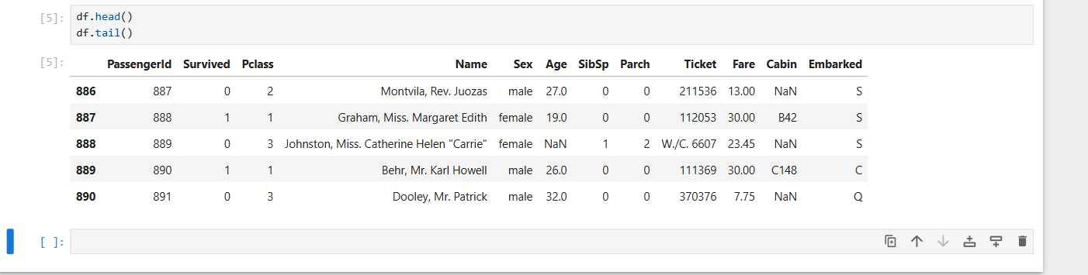3. Data Selection & Filtering
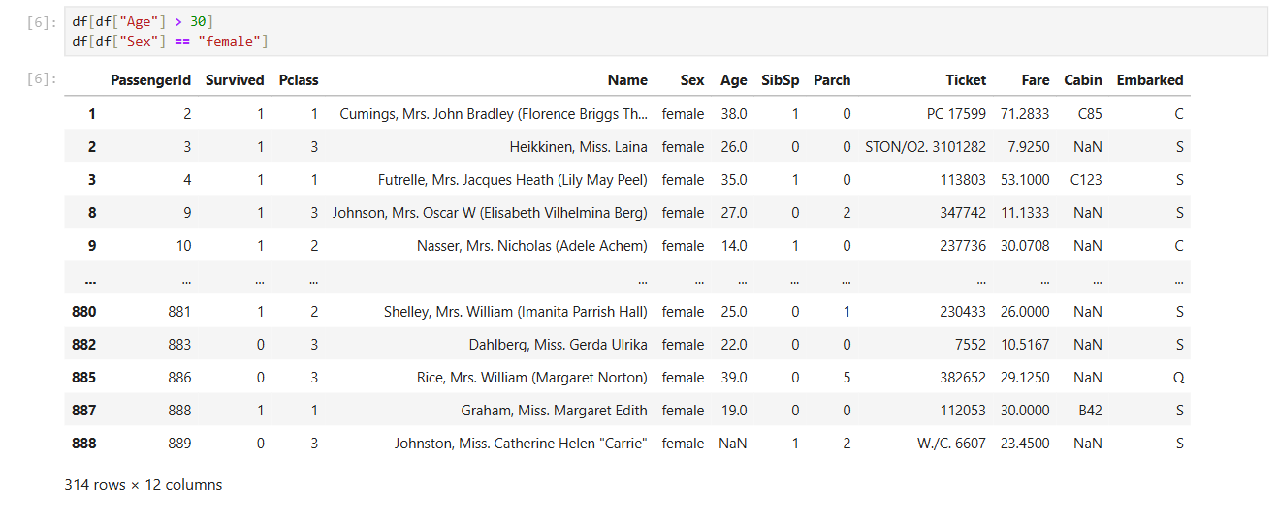
4. Sorting Data
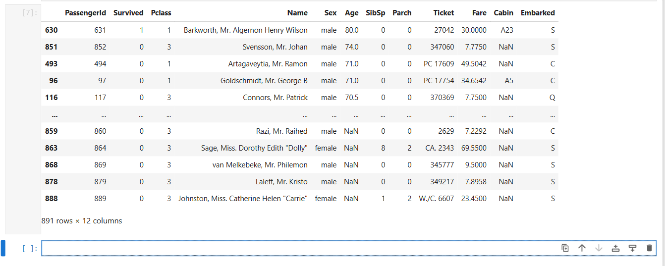
5. Handling Missing Data using isnull(), fillna(), dropna()
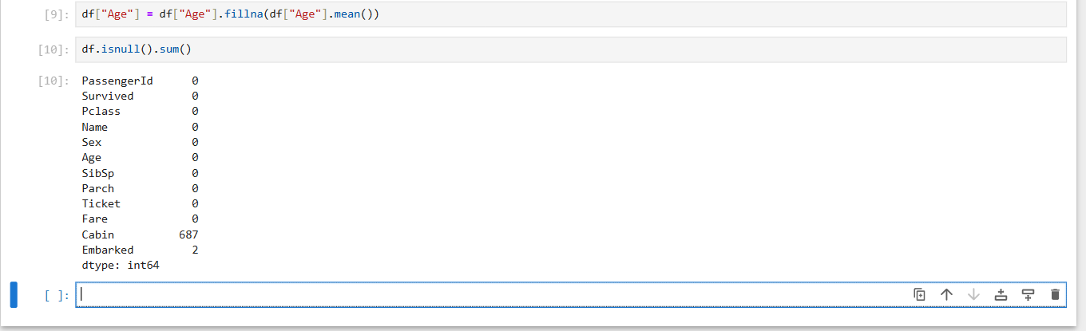
6. Column Operations (Add, Remove, Rename)
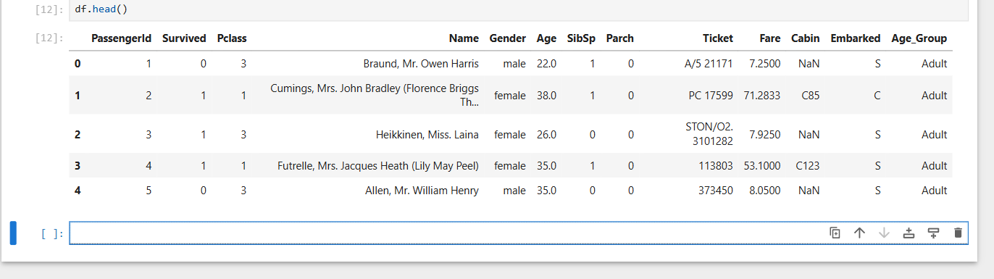
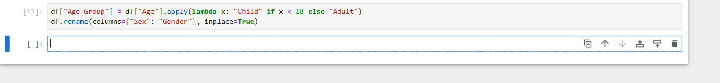
7. Final Cleaned Data Output

Conclusion
This task helped in understanding data preprocessing, cleaning, and manipulation using Pandas effectively.

